Macintosh HD:Users:Stephr91:Desktop:untitled folder:PRSB logo - CMYK.eps



FHIR® Proof of Concept

Evaluation Report

Macintosh HD:Users:Stephr91:Desktop:untitled folder:Better records - purple.eps

**Acknowledgements**

This project was funded by the NHS Digital, the trusted national provider of high‐quality information, data and IT systems for health and social care. NHS Digital collects, analyses and publishes national data and statistical information as well as delivering national IT systems and services to support the health and care system. The information services and products are used extensively by a range of organisations to support the commissioning and delivery of health and care services, and to provide information and statistics that are used to inform decision‐making and choice.

**The Professional Record Standards Body**

The independent Professional Record Standards Body (PRSB) was registered as a Community Interest Company in May 2013 to oversee the further development and sustainability of professional record standards. Its stated purpose in its Articles of Association is: “to ensure that the requirements of those who provide and receive care can be fully expressed in the structure and content of health and social care records”. Establishment of the PRSB was recommended in a Department of Health Information Directorate working group report in 2012.

**Copyright**

This document has been prepared by the Professional Record Standards Body (PRSB) on behalf of NHS Digital.

You may use and re-use the information featured in this document (not including logos or images) free of charge in any format or medium, under the terms of the Open Government License.

Any enquiries regarding the use and re-use of this information resource should be sent to: support@theprsb.org

Where we have identified any third party copyright material you will need to obtain permission from the copyright holders concerned.

Information and content © NHS Digital 2016

**Professional Record Standards Body**

**32 -36 Loman Street,**

**London SE1 0EH**

**www.theprsb.org**

Community Interest Company No 8540834

Document Management

|  |  |  |  |
| --- | --- | --- | --- |
| **Project** | FHIR® Proof of Concept (PoC) |  | |
| **Project Director** | Martin Orton |
| **Owner** | Thomas Hobbs | **Version** | 1.0 |
| **Authors** | Thomas Hobbs; Martin Orton |
| **Version Date** | 05/12/2016 | **Status** | Final |
|  |  |  |  |

Revision History

|  |  |  |
| --- | --- | --- |
| Version | Date | Summary of Changes |
| 1.0 | 29/11/16 | Final Version as Approved by the Project Board |
| 1.1 | 05/12/16 | Changes to the Executive Summary to make accessible for lay people. |

Glossary of Terms

|  |  |
| --- | --- |
| Term / Abbreviation | What it stands for |
| ANSI | American National Standards Institute |
| API | Application Programming Interface |
| C4H | Code4Health Interoperability Community |
| CDA | HL7 Clinical Document Architecture® |
| CKM | Clinical Knowledge Manager (a commercial product for viewing and collaborative reviewing of OpenEHR archetypes) |
| Composition | A FHIR Resource equivalent to a document, formed of a collection of other Resources for a particular use case (e.g. referral, investigation report). See http://hl7.org/fhir/composition.html |
| Connectathon | A collaborative laboratory for participants to test and develop interoperable software in a managed yet informal way, using test servers and pre-defined implementation scenarios. Connectathons can involve clinical users who test and review from an operational practitioner perspective. See <http://wiki.hl7.org/index.php?title=Clinicians_on_FHIR> and <http://wiki.hl7.org/index.php?title=FHIR_Connectathon_13> |
| dm+d | NHS dictionary of medicines and devices |
| DSTU2 | Draft Standard for Trial Use version 2, the current release version of FHIR |
| STU3 | The planned next release version of FHIR |
| EPR | Electronic Patient Record |
| Extension | In FHIR, extensibility is a fundamental part of the specification design. Every element in a Resource may have extension child elements to represent additional information that is not part of the base definition. See <http://hl7.org/fhir/extensibility.html> |
| FHIR | HL7 Fast Healthcare Interoperability Resources®. The FHIR specification is a "platform specification" - it creates a common platform or foundation on which a variety of different solutions are implemented. See <http://hl7.org./fhir/> . |
| HIU | Health Informatics Unit of the Royal College of Physicians |
| HL7 | Health Level Seven®. An international healthcare information standards development organization. |
| HL7 UK | The UK affiliate body for HL7 International. |
| HL7 UK ballot | The formal HL7 process for seeking approval of a draft specification, operated by the national affiliate of HL7 International that is responsible for promoting and advising on the implementation of HL7 standards within the given realm, in this case HL7 UK. |
| HL7 v3 | A set of messaging standards developed by HL7 that also incorporates CDA documents. |
| Implementation Guide | In FHIR, a coherent and bounded set of FHIR adaptations (“profiles”) that are published as a single unit. Validation occurs within the context of the Implementation Guide. See <http://hl7.org./fhir/profiling.html> |
| INTEROPen | An OPEN collaboration of individuals, industry, standards organisations and health and care providers who have expertise in interoperability, who have agreed to work together to accelerate the development of open standards for interoperability for the UK |
| LOINC | Logical Observation Identifiers Names and Codes |
| NHS Digital | The national provider of information, data and IT systems across health and social care |
| PID | Project Initiation Document |
| PRSB | Professional Record Standards Body for Health and Social Care |
| Profile | An adaptation of a FHIR Resource for a particular context of use. Typically, these adaptations specify which elements of the base Resource are used or not, any additional elements that are added, rules about terminology for particular elements and descriptions of how the Resource elements map to local requirements and/or implementations. See <http://hl7.org./fhir/profiling.html> |
| RCGP | Royal College of General Practitioners |
| RCP | Royal College of Physicians |
| Resource | A unit of health and social care information (including concepts involved in the process of care delivery) as defined in the FHIR specification (e.g. Patient, Practitioner, DiagnosticReport, Observation, Condition, Procedure) |
| SNOMED CT | Systematized Nomenclature of Medicine –Clinical Terms |
| ToC | Transfer of Care |

Reviewers

This document must be reviewed by the following people:

|  |  |
| --- | --- |
| Reviewer name | Title / Responsibility |
| Martin Orton | PRSB, Programme Director |
| Lorraine Foley | PRSB, CEO |
| Dr Philip Scott | PRSB technical assurance lead |
| Dr Phil Koczan | PRSB clinical and patient assurance lead |
| Dr Amir Mehrkar | GP, INTEROPen member (Orion Health), RCGP Health Informatics Group |
| Richard Kavanagh | NHS Digital, Head of Interoperability Standards Development |
| Dr David Stables | GP, INTEROPen member (Endeavour Charitable Trust) |
| Dr Wai Keong Wong | Consultant Haematologist UCLH, Co-chair National Pathology Advisory Group (RCP representative) |
| Keith Strahan | Social Worker, PRSB member, representing the Association of Directors of Adult and Social Services |
| Dr Anoop Shah | Specialist Registrar in Clinical Pharmacology and General Medicine, RCP Health Informatics Unit Clinical Fellow. |
| Matthew Butler | Mental Health Nurse, RCN |
| Dr James Reed | CCIO, Consultant Forensic Psychiatrist, Royal College of Psychiatrists |
| Dr Munish Jokhani | NHS Digital, Clinical Engagement Lead |

Approved by

This document must be approved by the following people:

|  |  |  |  |
| --- | --- | --- | --- |
| Name | Signature | Date | Version |
| Project Board |  | 29th November 2016 | 1.0 |
|  |  |  |  |
|  |  |  |  |

Related Documents

These documents will provide additional information.

|  |  |  |
| --- | --- | --- |
| **Ref no** | **Title** | **Version** |
| [1] | Agreed Changes & Principles | 0.4 |
| [2] | ‘Condition’ Profile Mind Map | 0.3 |
| [3] | ‘Medications’ Profile Mind Map | 0.3 |
| [4] | ‘Medications and Medical Devices’ PRSB Information Model | 1.0 |
| [5] | INTEROPen – ‘Michael’s Journey’ | 0.1 |
| [6] | David Stables – ‘The Problem with Problem’ | 1.0 |
| [7] |  |  |

**Contents**

1. executive summary 11

2. introduction/purpose 14

3. project background 16

4. methodology 20

5. AGREED changes made to FHIR profiles 21

6. 'medications' FHIR PROFILE vs. 'medication and medical devices' prsb information model 23

7. INFORMATION MODELS AND FHIR PROFILE MIND MAPS………………………………..23

8. key agreed principles for future fhir profile development ..………..26

9. FHIR PROFILE VIEWING OPTIONS…………………………………………………………………..27

10. PROPOSAL FOR FUTURE ASSURANCE……………………………………………………………29

11. Implications for future fhir profile development………………………...31

10. APPENDIX A…………………………………………………………………………………………………..31

11. APPENDIX B…………………………………………………………………………………………………..31

12. APPENDIX C…………………………………………………………………………………………………..31

13. APPENDIX D………………………………………………………………………………………………….31

14. APPENDIX E…………………………………………………………………………………………………..31

**Executive Summary**

**Introduction**

In the digital age, technology has an essential role to play in improving care, transforming the relationship between clinicians, professionals and patients, and helping people to take more control of their health and wellbeing. The digital vision for health and care depends on the development of standards that allow clinical data to be shared precisely, accurately and interoperably, that is transferred from one computer (the electronic health record system) to another (e.g. smart phone, laptop, tablet).

FHIR (Fast Healthcare Interoperability Resources) is an emerging technical messaging standard specifically developed to support interoperability. What this will do is allow access to health care data held in electronic records anywhere, at any time, to any authorised person – on any computing platform. It could also facilitate use of data from electronic health and care records audit, research, service management, and policy making.

The Professional Record Standards Body (PRSB) has been investigating how FHIR standards can be developed and clinically and professionally agreed, ensuring that the very technical standards are consistent with good clinical practice, meet the needs of patients and care professionals and are consistent with the already published PRSB standards.

**Background**

FHIR differs from previous technical messaging standards in that it defines healthcare information in simple, generic content models using data at a much more granular level, known as resources. Examples are: Condition, Medication Statement, Allergies. These resources can be changed and extended, so that data can be adapted for different uses; FHIR supports real-time data exchange, as well as the exchange of documents, such as electronic hospital discharge summaries, which to date are most often exchanged as scanned .pdf files. The process of changing or extending the generic content model is called ‘profiling’. For the UK, these profiles are called CareConnect profiles.

**Objectives**

The PRSB conducted proof of concept work, in collaboration with NHS Digital, INTEROPen (an action group that promotes open standards for interoperability) and HL7 (an international standards developer) to test the following:

1)    Assure the content model of two FHIR CareConnect profiles, ‘Condition’ and ‘Medication Statement’ with an expert group of care professionals and data modellers.

2)    Use the learning to produce a methodology for developing and clinically assuring FHIR CareConnect profiles for use in the transfer of health and care information between systems in the UK.

A key aim of the project was to support faster development of UK standards for the exchange of health and care information in FHIR, drawing on existing work nationally and internationally and collaborating with the interoperability community to bring a greater focus on implementation of the standards.

**Method**

The clinical assurance of the FHIR CareConnect profiles “Condition” and “Medication Statement”, and the methodology was developed using a real-life case study of a patient with complex care needs (diabetes, alcoholism and anxiety) who has many interactions with professionals (clinical and social care) in a variety of different care settings. In these interactions, information about this service user’s “conditions” and “medications” needs to be made available to systems in various care settings.

The initial FHIR CareConnect profiles were provided by INTEROPen.  Clinical assurance was carried out through a series of four workshops, through a multi-disciplinary approach involving informatics experts, modellers and care professionals knowledgeable in informatics from across health and social care. Using online collaboration the project group was able to gather input from other informatics experts.

**Conclusions**

The proof of concept successfully addressed the objectives and provided the following conclusions and outputs:

* Two FHIR CareConnect profiles (‘Conditions’ and ‘Medication Statement’) received initial clinical and professional assurance.  Additional work is required for a full clinical safety review.
* A new agile approach is required to develop generic FHIR CareConnect profiles to support information exchange needs in health and social care, allowing for iterative development and refinement as the profiles are used in different scenarios.
* A set of nine recommendations (Section 7) were agreed for the development of generic FHIR CareConnect profiles. A key factor in these recommendations is the need for collaborative development from the outset including vendors, information modellers, informaticians, care professionals, ensuring all aspects and views are taken into consideration.
* The ability to extend FHIR allows existing UK and international profiles to be adapted for UK use, providing a useful starting point. Similarly, existing information models in PRSB standards can be used and incorporated into the FHIR standards.
* A high-level process is proposed (Section 9) for the collaborative development of UK generic CareConnect FHIR profiles involving NHS Digital, suppliers through INTEROPen, PRSB and HL7 UK. The methodology includes implementation testing through clinical connectathons, and clinical and professional assurance through PRSB. It is believed this process will be quicker than the existing methodology for developing transfers of care standards, and would support developing a library of assured generic FHIR CareConnect profiles.

1. **Introduction**

The PRSB’s work to date under NHS Digital’s ‘Transfer of Care’ work programme has focussed on the transfer of patient and service user records between health and social care organisations. As such, the associated headings, sub-headings and corresponding clinical/practitioner content were designed in the context of a particular use case, for example the ‘discharge summary’.

This proof of concept project aimed to present a different approach to standards development in the context of creating clinical records that support the exchange of information within and between care organisations to support patient care pathways. It brought together a range of clinical and technical experts and representatives of nursing and social care to agree on how to represent information from health and social care in more discrete elements, such as problems, medication, allergies, using the published open standard HL7 FHIR specification. The FHIR specification has a published list of care record elements (i.e. information models), referred to as “resources”. Due to the extensible and customisable nature of these resources, a process called “profiling” can be applied to these resources whereby the base care record element, or resource, is modified to suit national or local needs as well as the use case in question. In FHIR jargon, the baseline resource, such as Medication Order, is profiled to suit the use case in question through defining constraints pertinent to the use case e.g. use of SNOMED CT terminology, or use of the NHS number.

NHS England and NHS Digital, in collaboration with INTEROPen, and under the umbrella of the Code4Health Interoperability Community, is supporting a programme of work to establish a UK localisation set of generic FHIR profiles; these are being referred to as CareConnect FHIR profiles. The profiles were intended to be generic and therefore safely usable as the exchange of structured and coded data between systems and across use cases (including admission, outpatients, referral and A&E discharge - see Figure 1 below)and care settings including primary, secondary and tertiary care. Messaging in these different use cases will constrain the generic profiles in various ways – generic FHIR profiles are expected to represent 80% of the data needed for coded entries (<http://hl7.org/fhir/us/ccda/2016Sep/>). Assurance of the profiles was carried out in a series of workshops involving healthcare practitioners and suppliers complemented in offline discussions. Outputs of the project were to produce FHIR profiles with a limited level of assurance - testing and implementation of the profiles is beyond the scope of this project. The intention of this proof of concept was to clinically and technically agree on the structure of one of these CareConnect profiles (’Conditions’), with a second (‘Medication Statement’) if possible in the timeframe, so that they could be used across a range of use cases including admission, outpatients, social care and A&E discharge *(see Figure 1 below).*

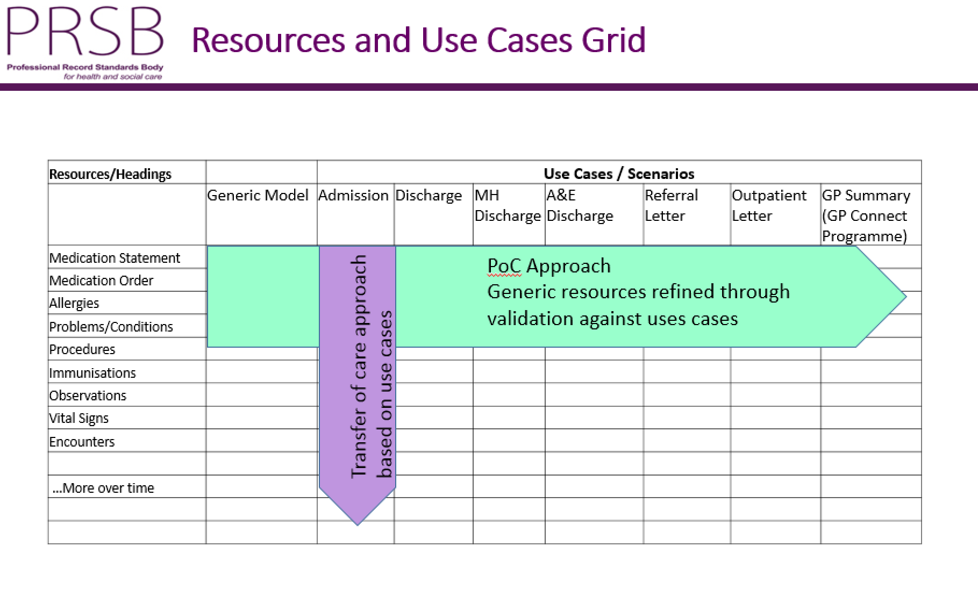

*Figure 1: Approach to assurance of generic CareConnect FHIR profiles compared to traditional records standards*

The proof of concept’s second, and perhaps more important objective, was to define an implementation-focused, practically driven methodology of CareConnect profile assurance, ensuring outputs were safe to use across health and social care. A working methodology principle was applied from the start that had two parts: a practically-driven, first pass process (mentioned above) to ensure the CareConnect profiles are fit for use, highlighting key clinical, social and technical recommendations, with the second pass process involving wider interoperability stakeholder review processes to test the profiles are not unsafe to use (Section 9). The processes consist of input from NHS Digital, HL7 UK, vendors through the INTEROPen group, and the PRSB being responsible for rendition of the information models (data modelling), and bringing together technical and health and social care professionals to provide assurance.

The involvement of clinical informaticians at the earliest stage was essential to ensure that these profiles were fit for purpose across health and social care systems. Development of the CareConnect profiles supports the NHS England’s new models of care initiative (see <https://www.england.nhs.uk/ourwork/futurenhs/new-care-models/>), where information can be retrieved from host IT systems in real time to support the direct care of patients.

The CareConnect Condition FHIR profile was chosen to be the first profile to validate for use across a range of use cases; a pragmatic methodology approach to the clinical/practitioner assurance of this profile’s information model will serve as a template recommendation for future CareConnect profile clinical assurance.

Although the approach aimed to produce generic information models (represented as CareConnect FHIR profiles), the workshop discussions adopted a realist but complex clinical and social care use case to assist practitioners to think through the information requirements.

The given use case was “Michael’s story” ([http://interopen.org/content/IO4%20-%20Mich’el's%20Story%20-%20Introduction.pdf](http://interopen.org/content/IO4%20-%20Michael's%20Story%20-%20Introduction.pdf)), a 58 year old man suffering with diabetes requiring insulin, alcohol dependency complicated by anxiety and liver disease who is interacting with at least six different care domains (primary care, acute, mental health, community, social care and self-care). Michael’s story in turn contains several transfer of care use cases including urgent care, referral, outpatient and discharge to community care. ‘Michael’s story”, his health and care needs and interactions, are outlined in detail in Appendix C.

It is recognised that Michael's story should have a greater social care narrative to bring in wider interoperability engagement with the social care sector (e.g. staff from Local Authorities and the Independent Care Sector including Care Homes, Domiciliary Care, providers, staff, vendors, etc.). A recommendation is to ask social care clinical leads to enhance Michael's story and an updated version will be shared via INTEROPen. The workshops considered the following key areas as part of developing the methodology for assuring and developing generic clinical information models to be represented in HL7 FHIR standard:

* Understanding what discrete health and care information elements are missing in the FHIR base Resource and to suggest modifications (profiling) as part of the curation of CareConnect UK profiles (e.g. NHS number, Social Care terminology, etc.);
* Considering how to present the information models to health and social care professionals, patients/service users and carers, who are not informatics specialists and to allow them to feedback, to enable wider assurance;
* Understand how the generic CareConnect UK profiles would be further constrained for particular use cases e.g. urgent referral, discharge summary.

The expert group reviewed and refined the information models throughout using their broad knowledge and skills to deliver a model which is validated for use (see Figure 2 below). By its very nature this POC represented a very limited health and social care professional assurance compared with the full PRSB process which engages widely with key professionals in the relevant areas through a large workshop followed by extensive consultation.

This document is a final report of the outcome of the proof of concept and provides a description of the methodological approach taken to providing limited assurance to the CareConnect profiles developed (first pass). The proposal that follows outlines the methodology of a more scaled-up assurance process, aligned with the process of full assurance (second pass) adopted by the PRSB in previous records standards projects.

1. **Project Background**

**National drivers: Transfer of Care initiative**

The Transfer of Care (ToC) initiative is part of a wider interoperability programme run collaboratively by NHS England and NHS Digital. Its focus is the adoption of consistent professional and technical information standards for the exchange of care information across health and care organisations. Of particular interest is the patient documentation and associated messaging which accompanies a patient/service user’s transfer of care between care provider organisations, such as discharge from Emergency Departments to GPs. Previous PRSB projects have aimed at producing practitioner-validated standards related to a single use case. These have then been converted into a technical document exchange standard (HL7 Clinical Document Architecture (CDA)) by NHS Digital for system suppliers to implement.

The NHS Standard Contract for 2016/17 mandates the use of clinical headings, that form part of these CDA documents, in electronic discharge summaries, and recommends structured messaging be used. The GP Systems of Choice contract (see <http://systems.digital.nhs.uk/gpsoc>) requires the GP IT system suppliers to deliver the capability to receive CDA (clinical document architecture) message-based discharge summaries directly into the primary care systems. Historically, industry’s preferred direction has been to enable CDA as the technology for use in the transfer of data within and between health and social care providers. Future contracts are likely to include the requirements of social care e.g. local authorities and care homes. Therefore, future CareConnect profile development must include consideration of the information model needs of social care providers.

**FHIR®**

FHIR® – Fast Healthcare Interoperability Resources (hl7.org/fhir) – is an open standards framework created by HL7. FHIR applies a practical focus on implementation, and manages information in the patient record at a more granular data-centric level, allowing systems to retrieve more granular data elements of the patient record, for example, related to a transfer of care without the traditional need to retrieve an entire document. Vendors and implementers are enthusiastically and rapidly adopting FHIR internationally, for example, the work underway in the form of the DAF Programme in the US: <http://hl7.org/FHIR/us/daf/2016Sep/daf-core.html>. INTEROPen, is developing a similar approach in the UK.

**HL7**

Health Level Seven International (<https://www.hl7.org/index.cfm>) is an organisation dedicated to providing a comprehensive framework and related standards in support of interoperability and ensuring the safe transfer of patient records. HL7 is supported by more than 1,600 members from over 50 countries, and is accredited by the American National Standards Institute (ANSI). HL7 UK is the UK branch of the organisation, and will be a key stakeholder in the future development of FHIR profiles for use in the NHS, from an international technical standards perspective.

**INTEROPen**

INTEROPen was initially established as a vendor arms-distance subgroup of the Code4Health (C4H) Interoperability Community (<http://www.techuk.org/insights/news/item/8393-call-for-action-interoperability-implementation-at-scale-interopen>) and is represented by a group of technical and clinical informaticians from a growing group of suppliers. It takes an open, collaborative approach to standards development and aims to accelerate the decision-making process of defining interoperability standards within the NHS by making specific recommendations in the approaches to emerging work. INTEROPen now welcomes membership from any individual or organisation interested in developing interoperability standards.

**Code4Health**

The Code for Health Interoperability Community (C4H) promotes health and care interoperability and provides an open platform for collaborative work on current and emerging technologies and standard development. A key objective of the community is to promote open API innovation and accelerate the transfer of knowledge, best practice and the patient experience generally across the system. In particular, it aims to provide recommendations on which parts of the interoperability architecture should sit with national organisations and which should be managed locally.

### **NHS Digital**

NHS Digital is the national provider of high‐quality information, data and IT systems across health and social care. NHS Digital collects, analyses and publishes national data and statistical information as well as delivering national IT systems and services to support the health and care system. The information services and products are used extensively by a range of organisations to support the commissioning and delivery of health and care services, and to provide information and statistics that are used to inform decision‐making and choice. NHS Digital has previously commissioned several PRSB projects, including the Clinical Structure and Content of Patient Records clinical record standards (CDGRS – 2013) for health and social care. For example, a new commission includes medical discharge summaries to Care Homes.

NHS Digital technical teams have been responsible for developing detailed Clinical Document Architecture (CDA®) specifications based on the clinically validated content of PRSB headings and accompanying information models.

**GP Connect**

GP Connect is a NHS Digital programme, run under the GPSoC contract, that is aimed at enabling access to a patient’s clinical information stored in GP systems. The programme has already published the API specification that will expose GP information in an unstructured HTML format. However, a key objective is to expose the GP information in a structured and coded form using the HL7 FHIR specification. CareConnect profiles in development will be adopted by the GP Connect programme, which is also developing FHIR based APIs to facilitate information exchange between systems (see <https://nhsconnect.github.io/gpconnect/index.html>). The GP Connect programme is working in collaboration with INTEROPen to accelerate the creation of a version 1 set of CareConnect profiles to expose GP data in a structured and coded form. This builds on previous work in the form of GP2GP (<http://systems.digital.nhs.uk/gp2gp>), which aimed to achieve interoperability between GP systems using HL7 v3, a complex messaging standard created by HL7 that underlies CDA. At present, it successfully transfers thousands of whole EPRs between GPSoc GP systems weekly when service users move to re-register at a new practice, demonstrating successful machine to machine level semantic interoperability.

**Professional Records Standards Body for Health and Social Care**

The PRSB ([www.theprsb.org](http://www.theprsb.org)) is the independent UK-wide organisation enabling professional and patient organisations to work together with the health informatics community and relevant government departments (e.g. NHS Digital) to ensure requirements for those who provide and receive care can be fully expressed in care records. PRSB is the mechanism through which the processes that produce care record standards are quality assured, by professional and patient/carer organisations, for usability in clinical and social care information systems.

The PRSB has been endorsed by the National Information Board (NIB) as the preferred route for clinical involvement in patient record keeping national activities and provision of patient and professional advice to NHS Digital. PRSB standards are embedded in the national policy of all four UK nations and are in the process of being implemented across the NHS. The PRSB has representation from all four UK nations, royal colleges and other professional bodies including social care, patients/service users and carers, and links into their relevant initiatives and networks. The full list of members is available here: <http://theprsb.org/about/who-we-are/our-members>

The PRSB Standards for the Clinical Structure and Content of Patient Records clinical record standards (<http://theprsb.org/publications/bible-sets-out-the-latest-agreed-standards>) for health and social care were published in2013. They provide clinically-assured professional record standards required under the NIB framework for action, ‘Personalised Health and Care 2020’, and were endorsed by fifty professional bodies and patient organisations. The PRSB are actively engaged with NHS Digital data standards and business analysis teams, supporting production of the CDA technical specifications of all developed record headings. Recent work has delivered phase two of an interoperable hospital discharge summary, which includes information models (developed with the Royal College of Physicians Health Informatics Unit as our delivery partner) for key structured and coded data on diagnoses, procedures, allergies and medications.

This document draws on previous projects and associated information models and describes the rationale, methodology, the stakeholders with whom the project team engaged, individual roles in the initial phase and the scaled-up proposal for future FHIR profile development.

1. **Methodology**

**Expert Group**

The expert group was chosen drawing on the advice of the PRSB clinical, practitioner and technical leads who identified candidate experts to provide the necessary input in the project and promote the use of the CareConnect profiles in their respective organisations. Four workshop sessions were set up for assurance of the clinical information model that would be represented technically within FHIR CareConnect ‘Conditions’ and ‘Medication Statement’ profiles. Methods of presenting the information models for an audience comprised of professionals across health and social care was a focus of the discussions. Consideration was also given to the most appropriate visualisation tools to share and generate clinical information models amongst clinicians in the future wider assurance stages. Workshops were led by the technical and clinical leads for the project.

A group of clinical informaticians across primary and secondary care, representatives from nursing and social care backgrounds and practitioners representing the interoperability community were brought together for this clinical assurance piece. The first workshop consisted of five experts (four of whom were also practicing clinicians; four of whom have a detailed knowledge of FHIR profiles), two GPs, a secondary care doctor, a nurse, a social worker, and a psychiatrist. PRSB, NHS Digital and INTEROPen were all represented in the consultation. A small project board consisting of representation from all stakeholders was held on 23rd November 2016 to sign off the outputs.

There was some variation as to who attended each session, however, all information was circulated using the ‘Ryver’ communication platform. ‘Ryver’ is a free team communication platform that allows conversations between team members without reliance on email. It allows all stakeholders to contribute to discussions between workshops, in both private and public chat forums and posts can be made within forums to discuss different issues. A ‘Conditions’ and ‘Medication Statement’ forum were set up to discuss matters related to those individual profiles; key changes, principles and actions agreed in the workshops were discussed on Ryver. Several health informatician experts, including additional representatives from NHS Digital, were also added to the forums to help inform the discussion and share their knowledge relating to existing PRSB information models for ‘Medications and medical devices’. The full lists of workshop attendees are available in Appendix B; the full process for the limited assurance of the clinical information models are outlined in Figure 2 below.

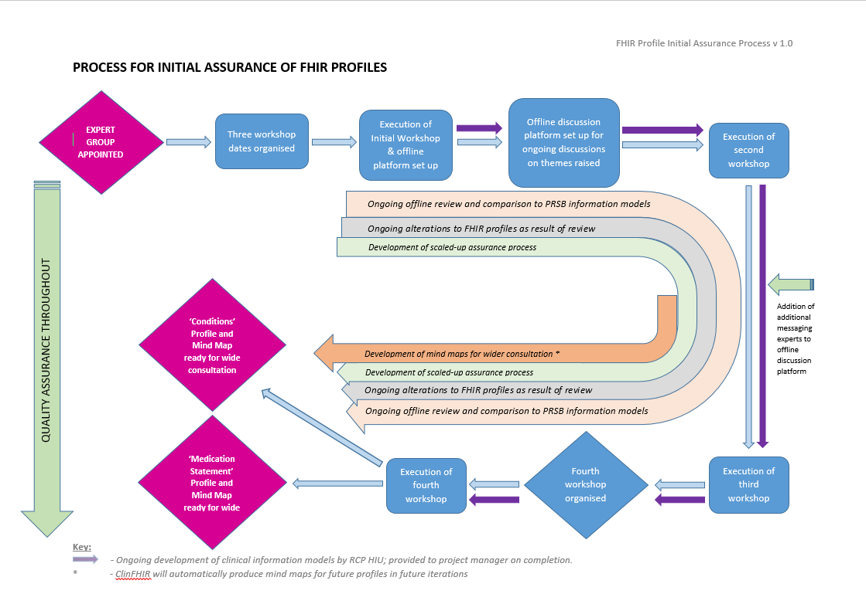

*Figure 2: Full process followed for initial clinical assurance of ‘Conditions’ and ‘Medication Statement’ FHIR profiles*

**FHIR Profiles and PRSB Information Models**

The FHIR profiles developed by experts in this proof of concept were derived from the work done amongst suppliers working within INTEROPen. In addition, NHS Digital, also members of INTEROPen, were represented by technical experts working on the GP Connect programme (<http://developer.nhs.uk/downloads-data/fhir-resource-definitions-library/>). This project took these profiles as a baseline, and in the context of ‘Michael’s story’, workshop members analysed the type of the clinical information that needed to be represented by them as Michael moved through his entire care journey. Any health and care information that was missing or needing further clarification were discussed, with changes applied to the profiles and emerging principles documented to produce profiles with limited PRSB assurance.

As delivery partners of PRSB, the Health Informatics Unit of the Royal College of Physicians provided the information model for ‘Conditions’ (embedded in Section 6 below). This was provided to the group for review ahead of the first workshop and for comparison with the underlying information model represented by the FHIR profiles being developed.

The information model ‘Medications and medical devices’ was developed in the PRSB Discharge Summary Phase 2 project, which focused on medications in a transfer of care context and how to render the key information required clinically into an information model for electronic messaging. Comparisons were made between the information models and the ‘Medication Statement’ FHIR profile developed as part of this project, as outlined in section 5. The high-level process/development flow for this review process is outlined in Figure 3 below.

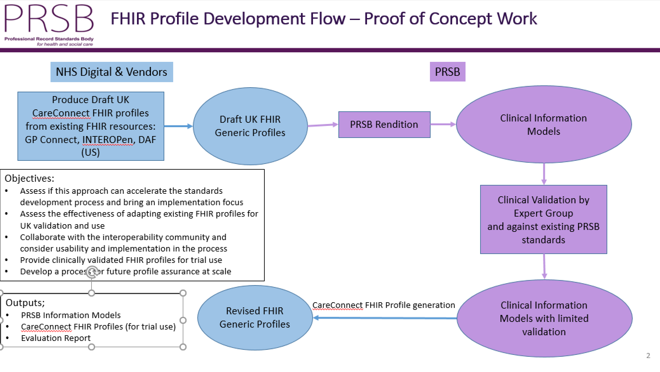

*Figure 3: Development Flow for FHIR proof of concept project*

The existing FHIR profiles for ‘Conditions’ and Medication Statement’ from previous work were deemed to be useful for this stage of assurance as they provided a good framework to begin the clinical assurance process and were also useful in comparisons with existing PRSB models

**Expert Group Workshops**

Due to the exploratory nature of this proof of concept, the approach taken to the initial workshop was generally unstructured. The technical lead for the project led the first workshop, which began with a learning session to ensure attendees had a common knowledge of the FHIR standard.

A paper produced by David Stables, an INTEROPen member, was used to inform the concept of what a patient “problem” is, in the context of Michael’s story (see Appendix E). The PRSB’s project ‘Standards for the Clinical Structure and Content of Patient Records 2013’ defines this as: *“Summary of problems that require investigation or treatment. This would include significant examination findings which are likely to have relevance, yet are not a diagnosis. In mental health and psychiatry, this may be the place for formulation”.* The “problem” (“Condition” in FHIR terminology) clinical information model was deliberately chosen to provide a complex area to ensure that difficult issues were addressed; in addition, the PRSB does not have an information model which could be directly mapped to it.

The ‘Medication Statement’ clinical information model was selected as part of a tranche high priority CareConnect profiles needed for Michael’s story, and where the PRSB has already developed a clinical information model, ‘Medications and medical devices’. However, this PRSB model was developed for the specific use case of discharge, while the FHIR CareConnect profiles are intended to be available to be applied across multiple use cases in Michael’s story.

1. **Agreed Changes to FHIR Profiles**

**‘Condition’ (i.e. Problem)**

Due to ambiguity of what a patient problem is, defined as from the perspective of the patient or the care professional, and its varying meanings across healthcare sectors (see ‘The Problem with ‘Problem’ – Appendix E) the workshops aimed to define its equivalents in primary care, secondary care, nursing, social care and mental health services. In the FHIR condition profile, any health or social care “problem” suffered by the patient (e.g. diabetes mellitus, or asthma, in any given terminology) can have a category value, which is a value from the value set of complaint, symptom, finding or diagnosis. In this particular profile, the category value set (complaint, symptom, finding, diagnosis) is extensible. The expert group determined that in GP systems, ‘problem’ is an appropriate category value, and hence ‘problem’ was added to the value set. Similarly, for social care, the data type “needs” was recommended as an extension to the value set, and “issues” for nursing.

In Local Authorities, social care assessments are required to take account of the care and support ‘[Needs](http://www.legislation.gov.uk/ukpga/2014/23/section/9)’ of adults and the support ‘[Needs](http://www.legislation.gov.uk/ukpga/2014/23/section/10)’ of carers as per UK legislation. Until the Care Act 2014 was introduced, ‘needs’ assessments tended to be focused on ‘a problem’ that needed to be solved by professionals and service(s) provided as required. Now the needs assessment encourages citizens to express their own self-perception of need, wishes and preferences and explore options and make choices about care provision. Understanding the more personalised interpretation and self-perception of ‘need’ is a fundamental premise of contemporary health and social care practice and should be appreciated in all domains.

These extensions to the value set allows for improved interoperability between systems and patient data recorded under ‘needs’ and ‘issues’.

As discussed earlier, an advantage of the FHIR standard is the extensible nature of profiles. Changes are relatively easy to make and they allow the core information content of the profile to be retained.

‘Body site’ was also reintroduced into the CareConnect “condition” profile. This concept was removed, or profiled out, from the international standard but reintroduced as part of Principle 4 outlined below.

**‘Medication Statement’**

In FHIR there are four types of resources to represent medication information and functions.

* Medication Order - An order for both supply of the medication and the instructions/recommendations for administration of the medication to a patient.
* Medication Administration - refers to when a patient has actually consumed a medicine, or has had it administered to them.
* Medication Dispense - usually in response to a prescription, and is defined as ‘provision of a supply of a medication with the intention that it is subsequently consumed by a patient’).
* Medication Statement – This represents a record of a medication being taken by a patient or a medication that has been given to the patient, where the record is the result of a report from the patient or another clinician. It is separate from the prescribe > dispense > administer sequence, instead acting as a report that some or all of it has occurred.

Medication Statement was chosen for this proof of concept as it represents a ‘snapshot’ of what the patient is taking or is recommended to take, and thus fits well into the transfer of care context. The other profiles were out of scope for this proof of concept project.

As an example of a modification proposed to the CareConnect Medication Statement profile, ‘intended’ was added to the status field to indicate that a medicine may be taken some time in the future. This happens occasionally in transfers (discharges) between primary to secondary care, but can also happen in other scenarios in the healthcare system.

**5. ‘Medication Statement’ Profile vs. PRSB ‘Medications and Medical Devices’ Information Model**

The ‘medications and medical devices’ information model was developed in recent work done by the PRSB, working with the RCP HIU as its delivery partner, as part of work for an electronic Discharge Summary standard. They developed information models based on consultations with healthcare professionals from a wide range of disciplines. Comparisons between the two were discussed as a result of the third workshop. However, due to first-pass assurance of the ‘medications’ model taking longer than expected, it was necessary to continue discussions predominantly offline (see Recommendation 2 below).

From discussions between the RCP HIU, PRSB and INTEROPen colleagues developing the profile, it was decided that it fitted with the information model well generally. The information model was based on the latest OpenEHR archetype available on CKM (see Section 6 below), and may have been conceptually closer to the ‘MedicationOrder’ profile.

**Future Work Needed**

‘Continuation instructions” for a medication or “recommendations” from one clinician to another (e.g. hospital doctor to the GP) are other concepts not currently fully accounted for in the FHIR Medication Statement profile. In a medication context, this could be a recommendation from a clinician: “please review in 14 days and see if you can increase the dose.” It cannot yet be put into a computable form until further work is carried out. At present the information is accounted for in the FHIR profiles as free text information.

Future FHIR profile development work (e.g. Allergies; Immunisations) can be mapped conceptually to PRSB-developed headings and associated information models well (see Figure 1 above) and thus should be used in future profiles development work.

The profiles being developed by this proof-of-concept are generic, and as such will vary in different information exchanges across different use cases (for example, the differences between value set data used in messaging scenarios in primary and secondary care – see Recommendation 5 below). Implementation-level guidance would need to outline how profiles are constrained dependent on the use case. For example, messaging for a transfer of care from primary to social care would use the data type ‘diagnosis’ or ‘problem’ in the category element, whilst messaging from social care to primary care may will use the data type ‘needs’. However, ‘needs’, ‘diagnosis’ and ‘problem’ are all part of the same value set in the category element of the ‘Conditions’ profile.

FHIR is increasingly becoming the preferred messaging standard for patient/service user data and may become an alternative to CDA in the future. Future work will therefore need to assess the capability of FHIR in mapping previous work into discharge summaries that have to date used CDA as the preferred messaging standard.

Future work will need to acknowledge the fact that the next iteration of the FHIR specification (DSTU3) is due to be published in 2017. There is a potential issue for UK adoption in that DSTU3 proposes that the value set for vital signs MUST use LOINC codes (see <http://hl7.org/fhir/2016Sep/valueset-observation-vitalsignresult.html>) so that the 'SMART on FHIR' platform can have international interoperability. This issue needs to be tested with an audience across health and social care. ‘SMART on FHIR’ is primarily of value for the consumer healthcare market, so that apps and devices can interact with Personal Health Records. This is aligned with the NIB's 'Personalised Health and Care 2020: A Framework for Action' strategy (see <https://www.gov.uk/government/news/introducing-personalised-health-and-care-2020-a-framework-for-action>), which gives patients more control over and access to their health and care records, and aims to reduce the burden on carers and care professionals.

**6. Information Models and FHIR Profile Mind Maps**

   

The ‘Condition’ and ‘Medication Statement’ profiles have been displayed in mind map form, for use in further consultations (see above). These documents represent more clinician-friendly methods of presenting the information models as part of the clinical assurance methodology that is evolving. The ‘Profile – Condition.docx’ represents the method of presenting mind maps to practitioners and includes an area for review of the accompanying mind maps.

The latest versions of the CareConnect FHIR profiles will be stored in registries hosted and curated by HL7(<http://www.hl7.org.uk/> - see Recommendation 7 below).

1. **Key Agreed Principles for Future FHIR Resource Development**

Below is a summary of the key recommendations from the care professional and technical experts who participated in this proof of concept. Participants are from a range of health and social care disciplines, with varying technical backgrounds as laid out above, and represent the key stakeholders. Please refer to Appendix A – ‘Changes and Agreed Principles’ for the complete list of alterations to the international FHIR resources in creating the generic UK CareConnect profiles.

1. **Adoption of UK CareConnect FHIR profiles requires a collaborative process that brings together the interests of NHS Digital, Code4Health, PRSB, INTEROPen, HL7 UK, and all local implementers including health and social care practitioners.**

*An outline methodology has been agreed in principle by the main stakeholders, given in Section 9. Further work is needed to determine how best to resource and execute this model.*

1. **From the outset, CareConnect FHIR profiles need to be co-produced by health and social care practitioners and information modellers. Appropriate introductory FHIR training is necessary.**

*Collaborative development will help to assure that assumptions and ambiguities are addressed at the earliest stage to avoid unnecessary corrective work later. Participating practitioners will require an introductory level of training about FHIR (typically an hour or so plus some advance reading) to become productive. Future work should consider ongoing, accessible interoperability training for practitioners, with a focus on FHIR and information modelling, aligned with the finding from the Wachter Review (2016) that “A successful digital strategy must be multifaceted, and requires workforce development” – see* [*https://www.gov.uk/government/uploads/system/uploads/attachment_data/file/550866/Wachter_Review_Accessible.pdf*](https://www.gov.uk/government/uploads/system/uploads/attachment_data/file/550866/Wachter_Review_Accessible.pdf)*).*

*Practitioners should be drawn from all areas including those on the frontline, and vendors, who have a good understanding of health and social care informatics. The introduction of clinically assured PRSB information models should also be shared at this earlier stage to inform the FHIR profiling process. Differences between the FHIR standards and the PRSB information models should be assessed and identified as early in the process as possible. The PRSB information models have previously gone through the full PRSB assurance process, and as such are useful references for the consultation process and may influence the practitioner evaluation of the corresponding FHIR profiles.*

1. **Mind maps are the most appropriate format for presentation of FHIR profiles to health and social care practitioners for review.**

*A tool we have identified that has the capability for viewing FHIR profiles in this user-friendly way is clinFHIR (see* [*http://clinfhir.com/*](http://clinfhir.com/)*). We recommend that further work is undertaken to support and develop this tool. We have demonstrated that the FHIR profiles used in this proof of concept can be viewed in clinFHIR.*

*It was agreed by health and social care practitioners* *and informaticians in the second workshop that other presentation styles (e.g. CKM) would be too technical for many new to health informatics. CKM is designed around a different data modelling framework standard (OpenEHR). At this time, CKM does not natively support FHIR. However, CKM has built-in collaborative workflow features of clinical modelling; it would be wise to apply these concepts for any collaborative tooling for FHIR. CKM is also a commercial product, while clinFHIR is open source and therefore offers more flexibility for future development.*

1. **A general profiling principle is that data elements are not removed from the international FHIR resources unless absolutely necessary for usage in the UK (e.g. from a clinical safety perspective).**

*However, in the profiling process, new data elements can be added to the international resources, as permitted “Extensions” or additions to value sets. FHIR CareConnect profiles need to be tailored to be UK-specific. For example, the US uses LOINC coding in some situations (e.g. 'vital signs') that are not in use in UK. England uses NHS numbers exclusively, while other countries use different patient identifiers (e.g. CHI numbers in Scotland).*

*Minimising deletions of data elements or value sets from the international FHIR resources will limit any unnecessary development costs for vendors, whilst supporting care information to move across any provider organisations both locally, nationally and internationally in future.*

1. **Implementation guidance needs to be explicit about how the generic CareConnect FHIR profiles should be constrained and used in different uses cases.**

*For example, information using the Condition profile sent from GP systems to Hospital EPRs will contain diagnosis and problem value set data, whereas information from Hospital EPRs to GP systems are likely to only be populated by diagnosis value set data. Furthermore, the implementation guidance will help elucidate which information exchange and workflows are appropriate for automation (being handled exclusively by the system with no human input) versus those requiring practitioner judgement or intervention.*

*In the initial stages of improving system to system interoperability using FHIR, it was recommended that all workflows should be semi-automated (i.e. with practitioner and technical oversight), until complete automation is proven to be safe. We expect this to be part of the interoperability maturity journey that is iterated over time with the agile development process in place (Section 9). This in turn points to the increasing need to raise the interoperability education amongst practitioners and and technical teams operating in the health and social care informatics sphere.*

*For example, the 'Medication Statement' profile is applicable to a transfer of care context, but will need human (health and social care practitioner) oversight when being converted into an order to prescribe or dispense at this point in time.*

1. **The use of FHIR to exchange information as documents (“CDA-on-FHIR”) should be given consideration to support the transfer of care use cases.**

*Sometimes referred to as CDA-on-FHIR, FHIR profiles can be grouped together in a “composition” resource, to allow for the organisation of information into a document format to support the transfer of care use cases e.g. discharge summary. This is of particular importance in social care, where the structure or care records is often different from medical care and usually represents a narrative.*

*There are a number of examples of hospital discharge to social care. One is to Care Homes where the transfer of the medical discharge summary at the point of discharge is crucial. Another is to Local Authority social care departments using* [*Care Act 14*](http://www.legislation.gov.uk/uksi/2014/2823/pdfs/uksi_20142823_en.pdf) *compliant Assessment, Discharge and Withdrawal Notices (normally completed by Nurses) that support the discharge of hospital patients that are considered to have social care needs. A standard for this workflow already exists -* [SCCI2075 *Assessment Discharge and Withdrawal Notices between Hospitals and Social Services*](http://content.digital.nhs.uk/isce/publication/scci2075)*.*

1. **The collaborative process described in Recommendation 1 requires common repositories for “in development” and approved UK CareConnect profiles and their associated extensions. The recommendation is that these formally approved profiles are hosted by HL7 UK, with a clear indication of which profiles have or have not received some level of PRSB clinical assurance. The repositories should include examples of every extension and profile, as per the core FHIR specification.**

*One repository is essential for effective version control, and a clear indication of the level of assurance from health and social care practitioners is important from a clinical safety perspective. A FHIR profile being implemented with limited clinical assurance may result in a loss of critical information in messaging between systems, and thus have an impact on patient/service user safety and limit system to system interoperability.*

1. **The INTEROPen consortium is a welcome and promising initiative, and it is recommended that more of its members are encouraged to participate in FHIR profile development. Interim curation of profiles within INTEROPen should be aligned with the collaborative process described in Recommendation 1.**
2. **It is recommended that meaningful and wide stakeholder consultation (with health and social care practitioners, informatics specialists and vendors) is paramount to ensure the main implementation issues are exposed and addressed. FHIR development and implementation work occurring globally should also be considered in parallel to national or local activities.**

*This is true of both the initial limited practitioner assurance phase as well as the wider consultation with stakeholders. The creation of FHIR CareConnect profiles requires more technical input than previous PRSB standards projects due to the more limited knowledge from health and social care practitioners of the FHIR standard.*

1. **FHIR profile viewing options**

The following information model viewing tools were considered by the proof of concept. A tool was needed to present information models in a user-friendly way. It was decided that presenting information in the form of Mind maps were the best form for health and care professionals to review.

The tools listed below represent data modelling tools considered by the group; it was decided that clinFHIR was the best option (see Recommendation 3). It was recognised in the workshops that the tool was some way from being used for communication and collaboration in FHIR CareConnect profile development, and work was needed to automatically generate mind maps from the information models. During the course of this project, however, the tool has had some further development and production of the mind maps for the two profiles has been demonstrated. It was agreed that learning from the use of CKM and its built-in collaborative workflow features should inform further development of the clinFHIR tool.

*Table 1: Visualisation Tools Considered in Workshop Sessions*

|  |
| --- |
| Manually constructed mind maps and spreadsheets |
| Native Format (table; UML) |
| INTEROPen viewer:<http://www.interopen.org/candidate-profiles/convergence/CareConnect-Problem-Condition-1.html> |
| Simplifier viewer: <https://www.simplifier.net/> |
| ART-Décor - <https://art-decor.org/mediawiki/index.php?title=Main_Page> |
| ClinFHIR: <http://clinfhir.com/> |
| Forge editor (not currently under consideration for non-technical clinicians) <http://fhir.furore.com/Forge> |
| openEHR CKM: <http://www.openehr.org/ckm/> (does not support FHIR profiles) |

1. **Proposal for Further Assurance Process**

This proof of concept was scoped to provide limited clinical, practitioner and technical assurance in the development of generic CareConnect FHIR profiles. A scaled-up clinical and technical assurance process is needed to ensure they are safe for use according to ISB standard 0160. Traditionally the PRSB have used online surveys, with assessment of a standard based on one use case being the scope for each project.

It is suggested that a ‘connectathon’ approach might be the most effective for the first stage of further assurance work, due to the pragmatic nature of FHIR profile development. This would involve test servers and use case scenarios (as in ‘Michael’s story), with users across health and social care testing,reviewing and improving the content and messaging from the perspective of a practitioner. As outlined in Principle 2 above, clinicians and practitioners will need an introduction to FHIR from a technical expert, or ideally a clinician/practitioner with FHIR expert knowledge. A PRSB online consultation will then follow with a wide range of health and social care professionals, completing the clinical/social care assurance process. Once published, implementation activities may begin. Support and maintenance issues may be routed through the consultation process in the following tranche; otherwise a support & maintenance service at the PRSB (once approved) will ensure any further health and social care information modelling issues with the profiles are addressed and solutions found via the associated experts.

The connectathons will involve review of a ‘batch’ of profiles that have gone through the first-pass, limited assurance phase of the process. Work should begin quickly with respect to organisation of the connectathons to ensure good turnout from health and social care professionals for the time proposed, and representation across the breadth of clinical disciplines and social care. A range of disciplines are required to identify all the implementation issues that may exist. The collaborative profile development process below is a maximal model, and subject to the varying complexity and issues arising at the initial stage. Further discussion is needed to determine the number of profiles that can (and should) go through the process at any one time. It is predicted however that most future generic profiles will not involve the complexity of ‘Conditions’ and ‘Medication Statement’ in this proof of concept.

**Draft proposal for collaborative UK FHIR profiles and implementation guides**

The purpose of this proposal is to suggest how NHS, INTEROPen, PRSB and HL7 UK can work together effectively to develop FHIR products to support UK health and social care interoperability. This is a draft for discussion. For simplicity, “NHS” as used below means NHS Digital and related health and social care national programmes and agencies. The desired scope is UK, not just England, so will need wider consultation than the current discussions. This is a “maximal” process model – some requirements may take a simpler route (e.g. a BMI profile might not need a formal clinical/social validation process).

The proposal is to follow this model for the initial PRSB-assured CareConnect Condition profile from its current position in the lifecycle (first draft), and start subsequent work from the start of the cycle. The aim is to have an agile cycle that adds value not time – each stage has an elapsed time estimate, assuming that the unit of production is a FHIR CareConnect profile. FHIR Implementation Guides would take longer, subject to their complexity.

The time estimates assume an agreed programme of connectathons and other events scheduled for the year ahead to ensure sufficient participation. A complete cycle (from step 6) is estimated to take 13 weeks. Multiple profiles can be in progress at different stages of the lifecycle (given sufficient resources), so this proposal does not imply that ‘n’ profiles would take ‘n*13’ weeks to produce. It is expected that multiple profiles will be packaged up for the PRSB consultation and HL7 ballot stages. Suitable tools will be needed to support clinician visualisation and comment and issue tracking.

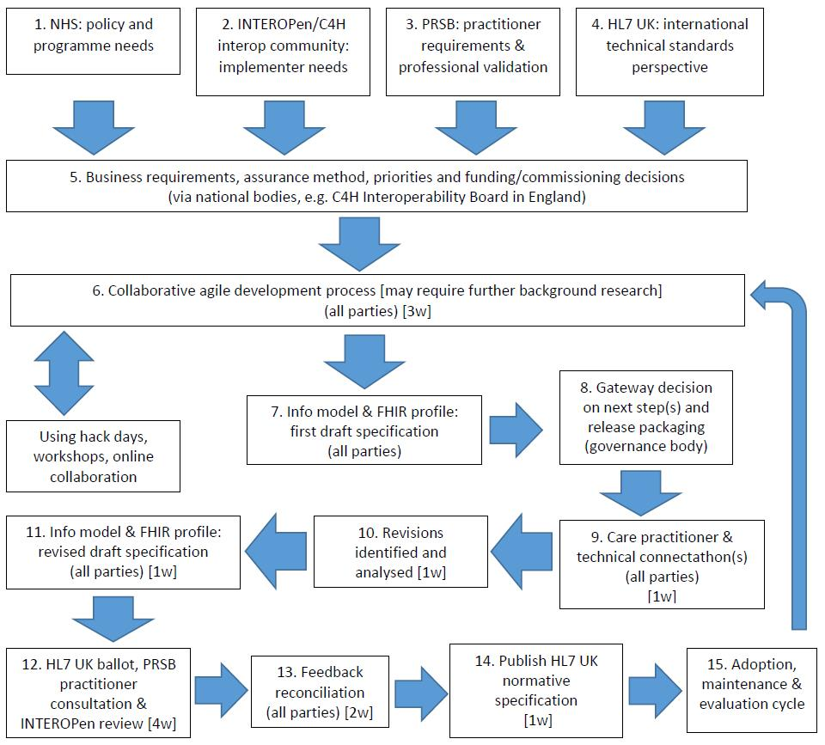

*Figure 3: Draft proposal for collaborative UK FHIR specifications (profiles and implementation guides).*

1. **Implications for Future FHIR Profile Development**

FHIR is being rapidly adopted internationally as a messaging standard framework, for example in the DAF work in the US (<http://hl7.org/FHIR/us/daf/2016Sep/daf-core.html>). The focus in health informatics is moving towards the ability to access information in real time as and when it is needed by care professionals and patients. FHIR (and associated API) supports the efficient and seamless exchange of information between systems at a more granular level. The nature of the profiles, and their ability to access smaller units of data related to a service user’s health and social care records frees data for use in new applications developed for care professionals (<http://www.nhs.uk/tools/pages/toolslibrary.aspx>). The NHS plans to publish a library of approved apps by March 2017 supported by recommendations from the Wachter Review (<https://www.gov.uk/government/uploads/system/uploads/attachment_data/file/550866/Wachter_Review_Accessible.pdf>). Apart from reducing administrative burden and improving efficiency for health and social care professionals and their processes, the applications of the FHIR specification will help to enable the ‘digitally enabled patient’ to readily access their health and social care data, giving them more control over their health and wellbeing.

The traditional focus on documentation related to health and social care transfers of care in the form of discharge summaries, however, should also be representable in FHIR. This is achievable through FHIR’s capacity to create ‘compositions’, which can build structures such as a discharge summary by combining profiles and elements of an EPR. These are particularly important in social care contexts. Future work will need to assess the capability of FHIR compositions, and how they can incorporate previous work into discharge summaries that have used, including information models generated and assured by the PRSB (see Recommendation 2 above).

Future profile development is likely to be based on prioritisation of the data needed most commonly in caring for the patient. This will be influenced by work into new models of care and are likely to include long term conditions including mental health (<http://theprsb.org/projects/improving-mental-health-information-for-discharge-into-general-practice>), and care for children and the elderly, areas being explored currently at the PRSB and in NHS Digital.

Driven by local needs, adoption of FHIR profiles and (more so) APIs could grow significantly. As the generic CareConnect profiles are implemented across a wider range of use cases, on-going iterative development, assurance and support will be required to build and maintain an effective library of assured FHIR CareConnect resources.

1. **Appendices**

**Appendix A: Changes to FHIR Profiles and Agreed Principles**



**Appendix B: Expert Workshop Attendees**

|  |  |  |  |  |
| --- | --- | --- | --- | --- |
|  | Workshop 1  14th September | Workshop 2 22nd September | Workshop 3 27th September | Workshop 4  7th October |
|
| Amir Mehrkar | **Y** | **Y** | **Y** | **Y** |
| Wai Keong | **N** | **Y** | **N** | **Y** |
| James Reed | **Y** | **N** | **Y** | **N** |
| Matt Butler | **Y** | **Y** | **Y** | **Y** |
| Keith Strahan | **Y** | **Y** | **N** | **N** |
| David Stables | **Y** | **Y** | **Y** | **N** |
| Anoop Shah | **Y** | **N** | **Y** | **N** |
| Philip Scott | **Y** | **N** | **Y** | **Y** |
| Phil Koczan | **Y** | **Y** | **Y** | **Y** |
| Munish Jokhani | **Y** | **Y** | **Y** | **Y** |

**Appendix C: ‘Michael’s Story – INTEROPen PowerPoint presentation**



**Appendix D: ‘Issues with Implementation’**



**Appendix E: ‘The Problem with Problem’ – David Stables document**

